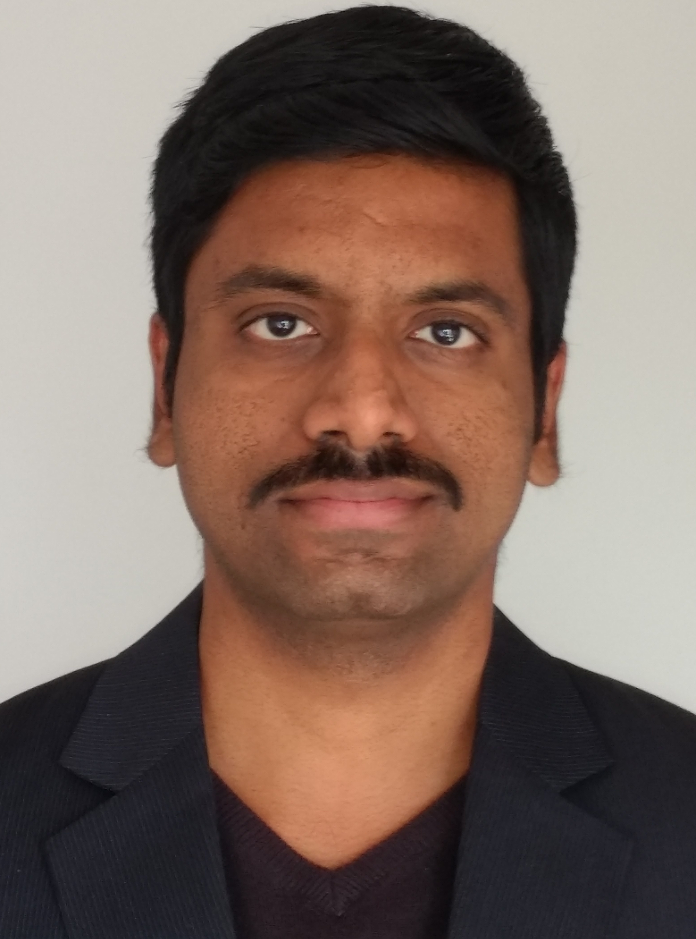
Nishanth Nagendra
#363, “AMOGH”, 5th Main,
Canara Bank Layout, Near Kodigehalli,
Vidyaranyapura Post, Bangalore 560097
+91-8197815322
nishanth.amogh@gmail.com

TECHNICAL SKILLS
Programming: C, C++
Platform: Linux
Programming: Pthread, Posix Socket API, Debugging tools (gdb, gprof, valgrind, splint),
Tools/Libraries Basic level usage of C++ STL, OpenMP, MPI, FICO Xpress Optimizer library
Project Mgmt.: ViM Editor, GNU Build System (Autotools), Git, Version mgmt. and Defect tracking
using IBM's Rationale Software, Basic level usage of Visual Studio / Eclipse IDE s

PROFESSIONAL EXPERIENCE
Research Assistant Jul 2014 – Oct 2016

Chair for Architecture of Parallel and Distributed Systems, Munich, Germany
Technical University of Munich
- InvasIC – Invasive Computing (http://invasic.informatik.uni-erlangen.de/en/tp_d3_PhII.php)
- Involved in research and development of an early prototype to support the resource management and scheduling of adaptive parallel applications on future HPC systems.
- Worked on a large scale open source software system called SLURM which has a distributed software architecture. Understanding the large code base followed by a new software architecture and design for the planned prototype.
- Collaborate with research group members who are involved in developing the invasive version of MPI and resource mgmt. to support adaptive MPI applications.
- Developing the support for visualization of runtime scheduling decisions in the Vampir tool with the help of Open Trace Format (OTF) library.
- Tech Specs: C, SLURM, OTF, Posix library (pthread, sockets), MPI, MySQL, Perl, gdb, valgrind, Autotools, git

- AutoTune – Automatic Online Tuning (http://www.autotune-project.eu)
- Enhancement of the performance capping plugin to implement and evaluate a simple linear regression technique to model the performance of an OpenMP application for energy efficiency and using the same for making simple predictions using Brent Algorithm.
- Evaluating the compiler flags selection plugin by testing it against various benchmark scientific applications for precision, robustness and performance.
- Tech Specs: C++, Autotune, Periscope Tuning Framework, OpenMP, gdb, valgrind, git,
Autotools

Senior R&D Engineer Aug 2011 – Sep 2013
Mavenir Systems (now Mitel) Bangalore, India
- Low level design, and, Implementation of new features in the AirMessenger messaging product.
- Involved in the enhancement of several modules relating to SMPP, billing, LDAP, traffic logging,
message receiver/delivery, message store, queuing, retrieval and retrying functionalities.
- Testing, Documentation and Product support for bug fixes after live deployment.
- Tech Specs: C, Posix Library, Wireshark, gdb, MAP, SMPP, DCCA, Postgres, IBM Rationale Suite

Software Engineer Mar 2010 – Apr 2011
Aricent Technologies Bangalore, India

- Implementing the support for migration of a VoIP product (Sonus ASX) from IPv4 to IPv6. This involved low level design, and, enhancement of protocol specific modules like SIP, DIAMETER etc. Performed unit, functional and system testing using scripts and softphones.
- Underwent training for 2 months on UMTS technology, product based training on RNC, Uplane software. Performed sustenance, feature enhancement and resolved small bugs.
- Simulation of X2AP – an LTE specification [at Aricent Training Facility]. A short team project which
involved programming with sockets, threads, Unix IPC facilities like message queues, and, pipes.
- Tech Specs: C, C++, TCP / IP Socket Programming, SIP, Diameter, Wireshark, gdb, valgrind, gcov, splint, IBM Rationale Suite, CVS

EDUCATION
Master of Science in Informatics Munich, Germany
Technical University of Munich, Oct 2013 – Jul 2016
GPA: 1.3 / 5.0 (1.0 – Best, 5.0 - Worst)

Bachelor of Computer Science and Engineering Bangalore, India
Atria Institute of Technology, 2005 – 2009 (GPA: 79.50 / 100)
Thesis Topic : Implementation of an Image Editing Software and A JPEG Compression Utility with the help of Matlab

ACADEMIC RESEARCH PROJECTS
Master Thesis: Job Scheduling for Adaptive Applications in Nov 2015 – Jul 2016 Future HPC Systems
Design, develop and evaluate a dynamic and flexible scheduling strategy for adaptive parallel
applications on future exascale systems. This approach is based on a new negotiation protocol
between batch and runtime schedulers and their new algorithms respectively. The framework has been
developed in C on SLURM which is highly scalable multithreaded and distributed open source software.

A Protocol for Integration of Invasive Resource Apr 2015 – Oct 2015 Management into Existing Batch Systems
Design, develop and evaluate a new negotiation protocol similar to the ones used in resource
management systems for Cloud. This is required in order to integrate invasive resource management
into existing batch systems. The open source product SLURM is used for the development purpose. A
new plugin has been developed in C for Slurm along with a dummy runtime scheduler.

Implementation of a Metaheuristic for the Discrete Dec 2014 – Nov 2015 Network Design Problem
Researched various metaheuristic approaches to solve discrete/continuous traffic network design
problems that are usually non-convex in nature and of the form of a bi-level linear program. Designed
and Implemented a Genetic Algorithm in C along with the Modeling and Solving of the optimization
problem using FICO Xpress Optimizer library in C++. Evaluated the algorithm under various settings
with small to large scale traffic networks for correctness, performance and effectiveness.

Parallelization of Applications using OpenMP and MPI Apr 2014 – Aug 2014
Parallelization of the given heat simulation code in C using OpenMP. Parallelization of the minimax and
alpha-beta search techniques in the given two player game (C++) called “Abalone” using MPI.

PERSONAL SKILLS
Organizational Skills: Experience working in small / large software development teams both in a flat and vertical hierarchy. Strong experience of the full software development lifecycle.
Language Skills: Proficient - Kannada, English and Hindi. Basic – German, Sanskrit
Hobbies and Interests: Dancing, Cooking, Biking, Playing Violin

